Open Rails

InstallationManual

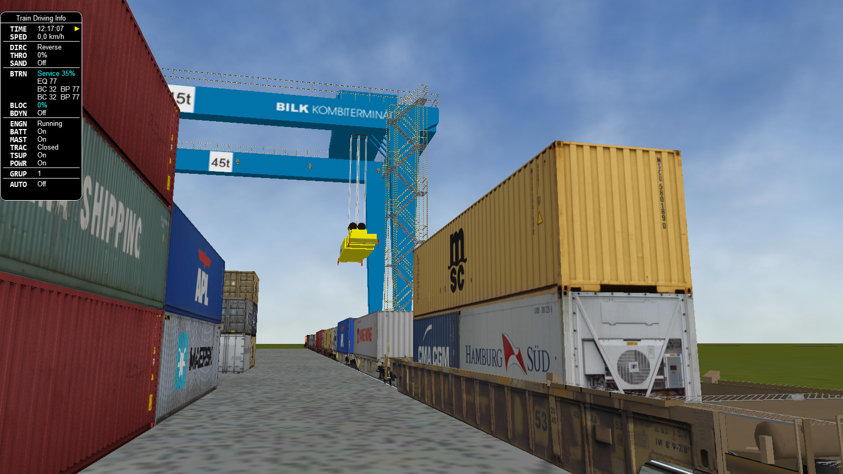

Table of Contents

Version 3

Overview 3

System requirements 3

Supported operating systems 3

For the future 3

Installation procedure 4

Installing Open Rails software 4

Upgrading from a previous download 4

Uninstalling Open Rails software 4

Video card settings 4

Using Open Rails with MSTS installed 4

Adding content 4

Checking your installation 5

Multi-Player 6

RailDriver® 6

Legal 7

Warranty 7

Trademark acknowledgment 7

License for the Open Rails software 7

License for this document 7

# Version

This document is based on version 1.5.

# Overview

## System requirements

Open Rails is an "AnyCPU" program which will run as a 32-bit program on 32-bit Windows and as a 64-bit program on 64-bit Windows.

It requires:

* Processor : 2.0 GHz (32 or 64-bit)
* Memory : minimum = 0.5 GB, recommended = 4 GB
* Hard drive : 50 MB (but models require lots of space. The 6 routes in Microsoft Train Simulator require 1.4 GB)
* Graphics : any compatible with Windows 7 upwards. (more than 0.3GB graphics RAM recommended)

## Supported operating systems

Open Rails works well on Windows PCs from Windows 7[1] onwards (including Windows 11). It does not work on Windows XBox, Windows Phone or non-Windows platforms.

## For the future

Open Rails software is aimed at the serious hobbyist. Open Rails software is being developed specifically for a trainsim community member who cares about loco physics, train handling, signals and intelligent AI behavior.We believe those users are willing to invest in a more powerful computer to ensure they get the results they want. Therefore, development of the Open Rails software will be focused on optimizing its performance on multi-core CPU systems with mid-to-high end graphics cards. It would be nice to support the less powerful computers, and it’s technically possible to do so but, with limited resources, the Open Rails development team assigns a lower priority to this.

# Installation procedure

## Installing Open Rails software

You can download the zipped install archive file at <http://openrails.org/download/versions/>

Then:

1. Open this archive file and extract all the files and folders to a suitable folder. We suggest C:\OpenRails.
2. Create a shortcut to file C:\OpenRails\OpenRails.exe (or a different path if you have not used C:\OpenRails as the install folder).

### Upgrading from a previous download

Multiple instances of Open Rails software can exist on your computer without any conflicts. Please check the path of any desktop shortcuts you may have created to ensure they reference the desired version of Open Rails software.

To upgrade, rename the previous installation folder and then carry out a fresh installation.

### Uninstalling Open Rails software

Simply delete the installation folder where Open Rails was installed.

### Video card settings

A setting for Vertical Sync is available in *Open Rails Menu > Options > Video.* There is also a setting the for Anti-aliasing.. Other video settings should be set in the control panel of your video card. The default settings in Open Rails will give a good appearance and performance.

## Using Open Rails with MSTS installed

Open Rails does not require any MSTS files to be present.

Open Rails software uses any Microsoft Train Simulator entries in the Windows registry to find where your Microsoft Train Simulator files might be located on your computer. If these are found, then Open Rails will include that MSTS content in its list in *Open Rails Menu > Options > Content*

## Adding content

Open Rails is a simulator and is not distributed with any content. You can find content (both free and commercial) at our home page <http://openrails.org/> and at <http://openrails.org/download/content/>

# Checking your installation

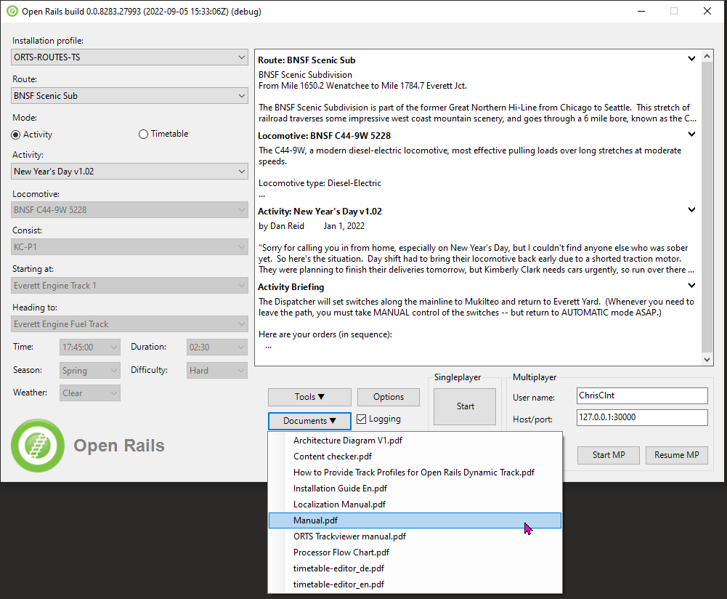Once you have added some content, then check your installation by following the instructions in th*e Manual > Getting Started*.

You can open the manual from the *Open Rails Menu > Documents > Manual.pdf* or read it on-line at <https://open-rails.readthedocs.io/en/latest/>

# Multi-Player

The standard installation also allows you to use Open Rails with friends. See the Multi-Player section in the manual.

# RailDriver®

You can use RailDriver® to run Open Rails. See the *Introduction > RailDriver Support* section in the manual.

# Legal

## Warranty

openrails.org disclaims any warranty, at all, for its software. The Open Rails software and any related tools, or documentation is provided “as is” without warranty of any kind, either express or implied, including suitability for use. You, as the user of this software, acknowledge the entire risk from its use.

## Trademark acknowledgment

Open Rails, Open Rails Transport Simulator, ORTS, Open Rails trademark, openrails.org, Open Rails symbol and associated graphical representations of Open Rails are the property of openrails.org. All other third party brands, products, service names, trademarks, or registered service marks are the property of and used to identify the products or services of their respective owners.

## License for the Open Rails software

Open Rails is free software: you can redistribute it and/or modify it under the terms of the GNU General Public License as published by the Free Software Foundation, either version 3 of the License, or any later version.

You should have received a copy of the GNU General Public License as part of the Open Rails distribution in Documentation\Copying.txt. If not, see [http://www.gnu.org/licenses/.](http://www.gnu.org/licenses/)

## License for this document

This work is licensed under the Creative Commons Attribution-NonCommercial-ShareAlike 3.0 Unported License. To view a copy of this license, visit <http://creativecommons.org/licenses/by-nc-sa/3.0> or send a letter to Creative Commons, 444 Castro Street, Suite 900, Mountain View, California, 94041, USA.

1. Windows 7 requires Service Pack 1 (SP1).